Set up the test environment

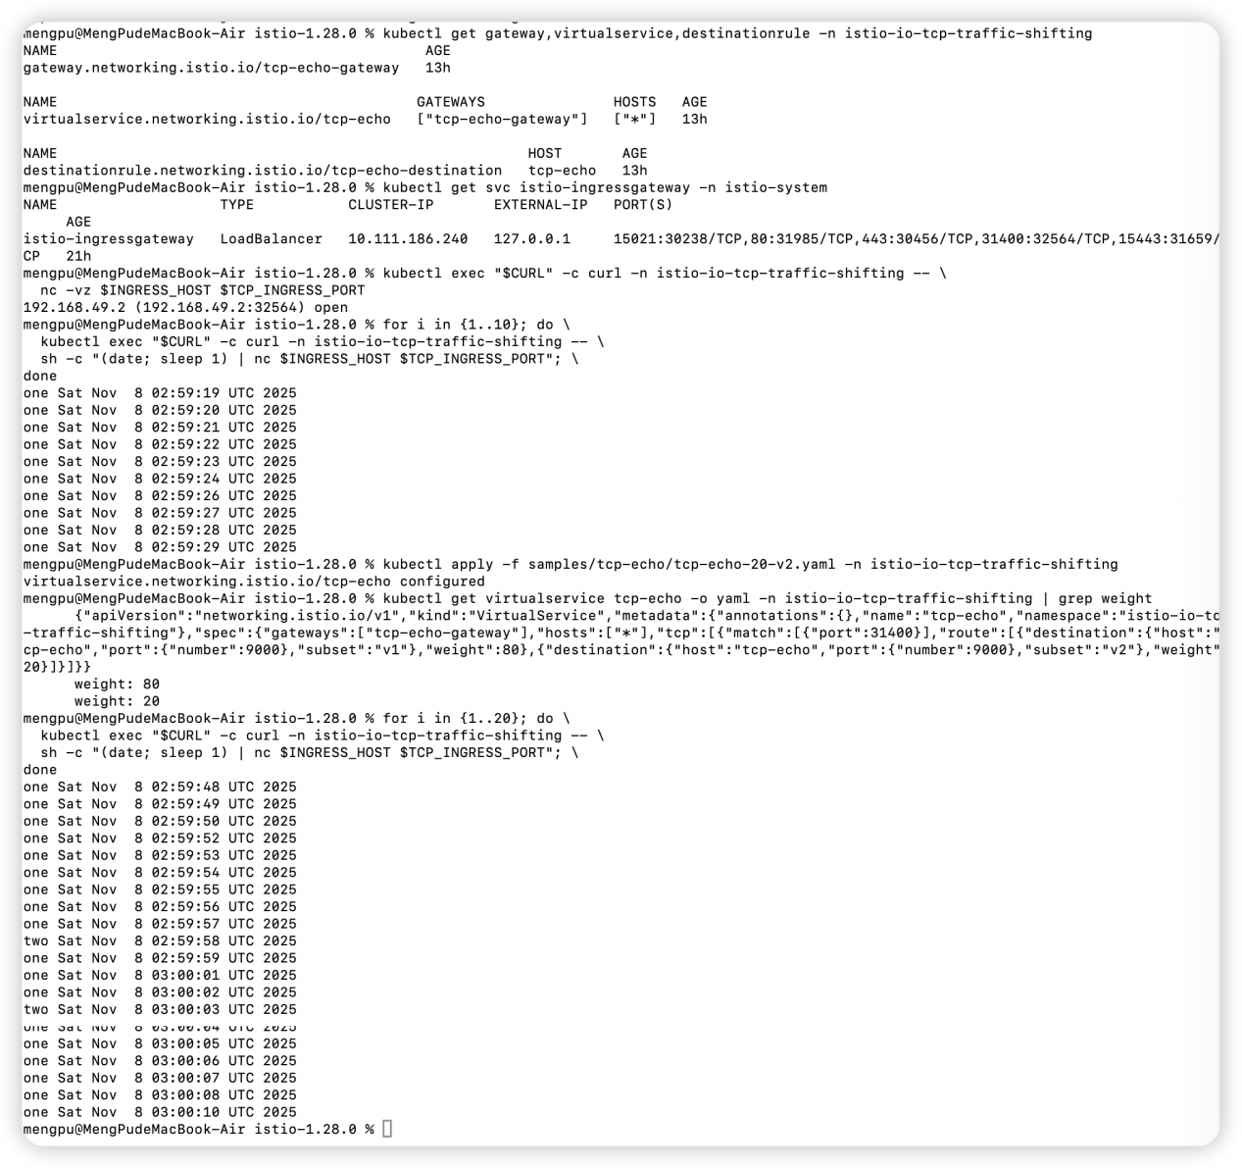100%V1 & 20%V2

